SF.SmokeTestScripts_TC_SF_ManagerLogin_Instance1_12-Apr-2017_01-28-10_PM_Invoke_Application.png



SF.SmokeTestScripts_TC_SF_ManagerLogin_Instance1_12-Apr-2017_01-28-16_PM_Invoke_Application.png

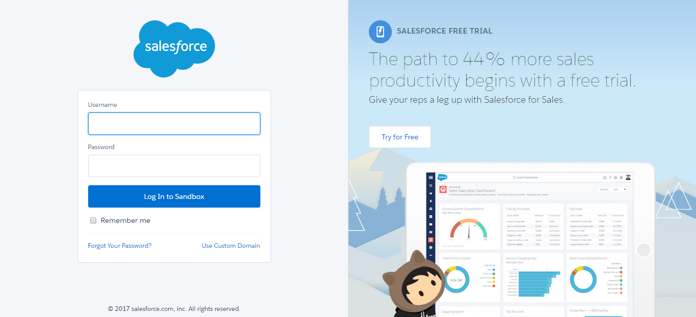

SF.SmokeTestScripts_TC_SF_ManagerLogin_Instance1_12-Apr-2017_01-28-22_PM_Login.png

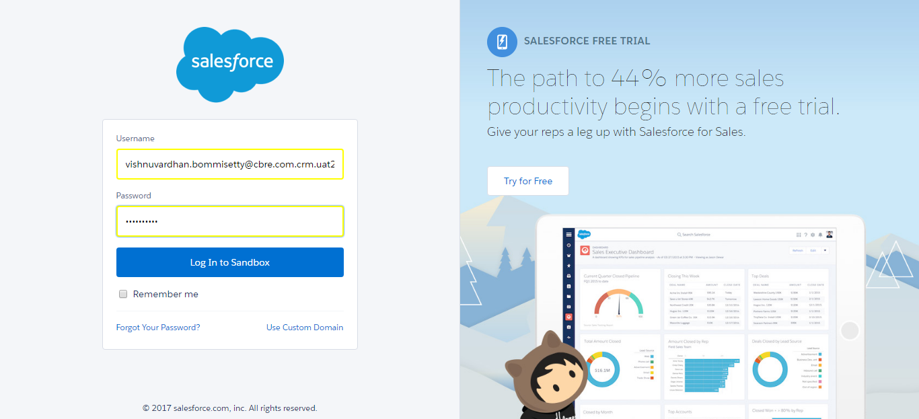

SF.SmokeTestScripts_TC_SF_ManagerLogin_Instance1_12-Apr-2017_01-28-31_PM_Verify_Login.png

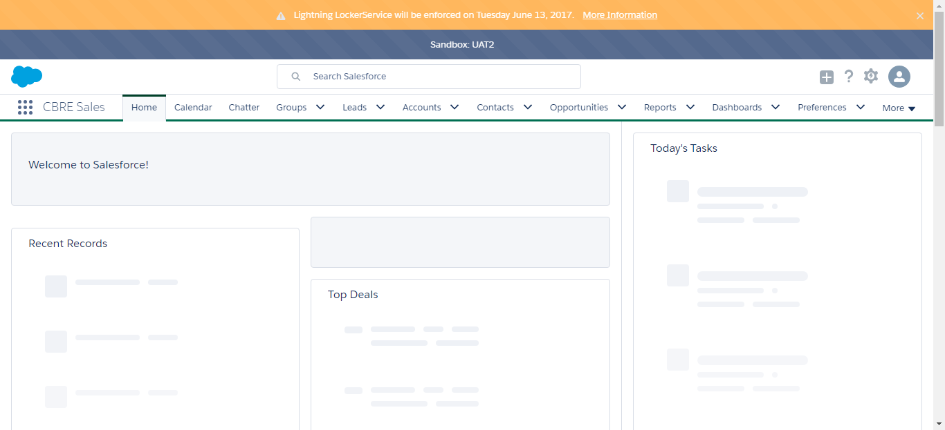

SF.SmokeTestScripts_TC_SF_ManagerLogin_Instance1_12-Apr-2017_01-28-37_PM_Verify_Logout.png

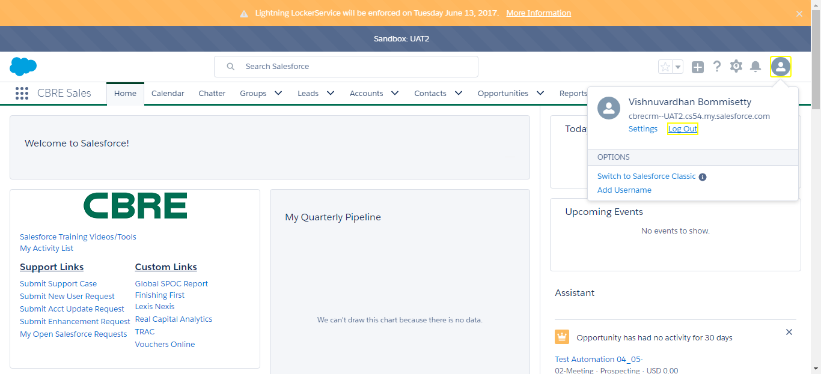

SF.SmokeTestScripts_TC_SF_ManagerLogin_Instance1_12-Apr-2017_01-28-49_PM_Invoke_Application.png



SF.SmokeTestScripts_TC_SF_ManagerLogin_Instance1_12-Apr-2017_01-28-54_PM_Invoke_Application.png

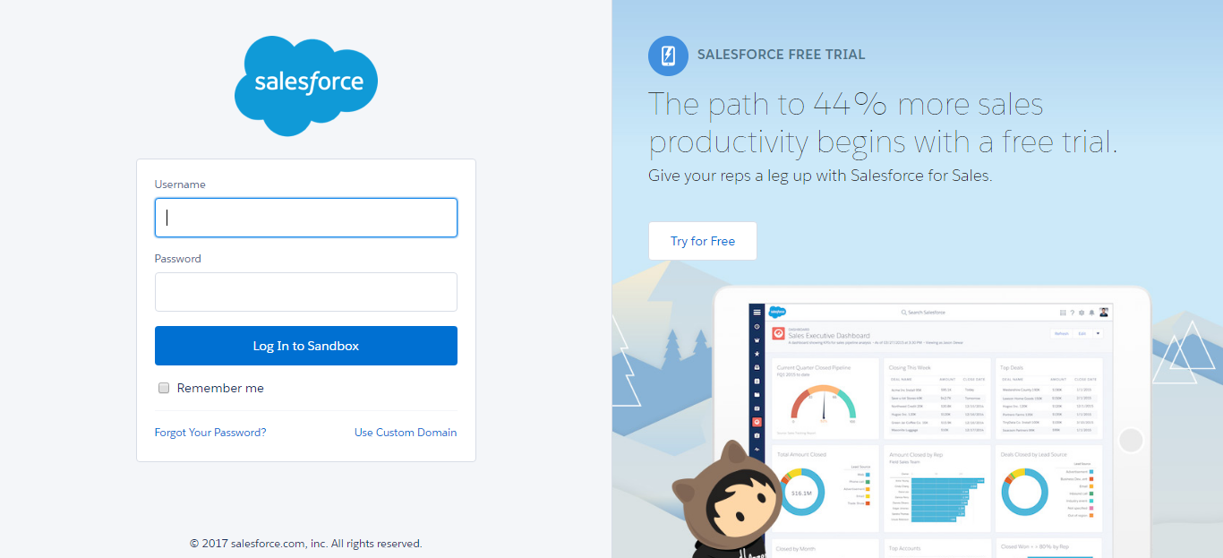

SF.SmokeTestScripts_TC_SF_ManagerLogin_Instance1_12-Apr-2017_01-29-00_PM_Login.png

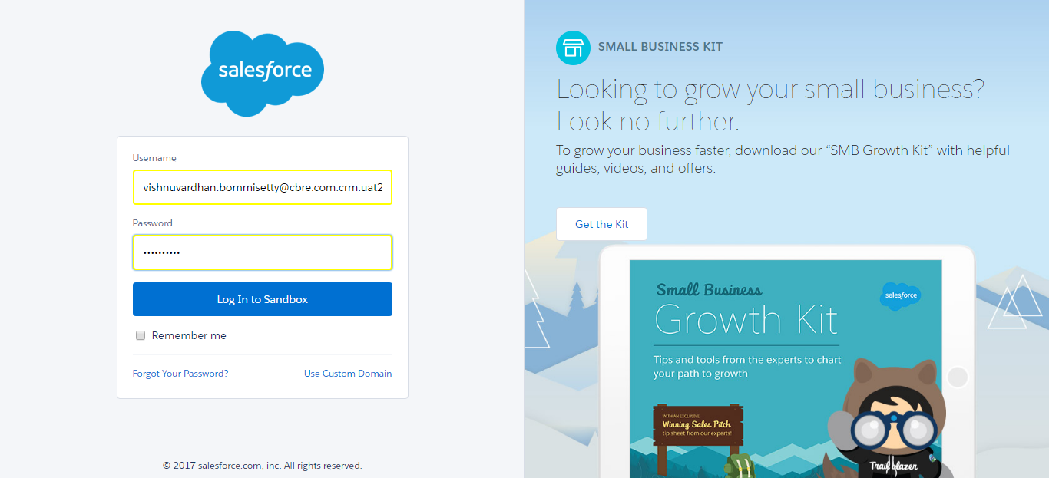

SF.SmokeTestScripts_TC_SF_ManagerLogin_Instance1_12-Apr-2017_01-29-09_PM_Verify_Login.png

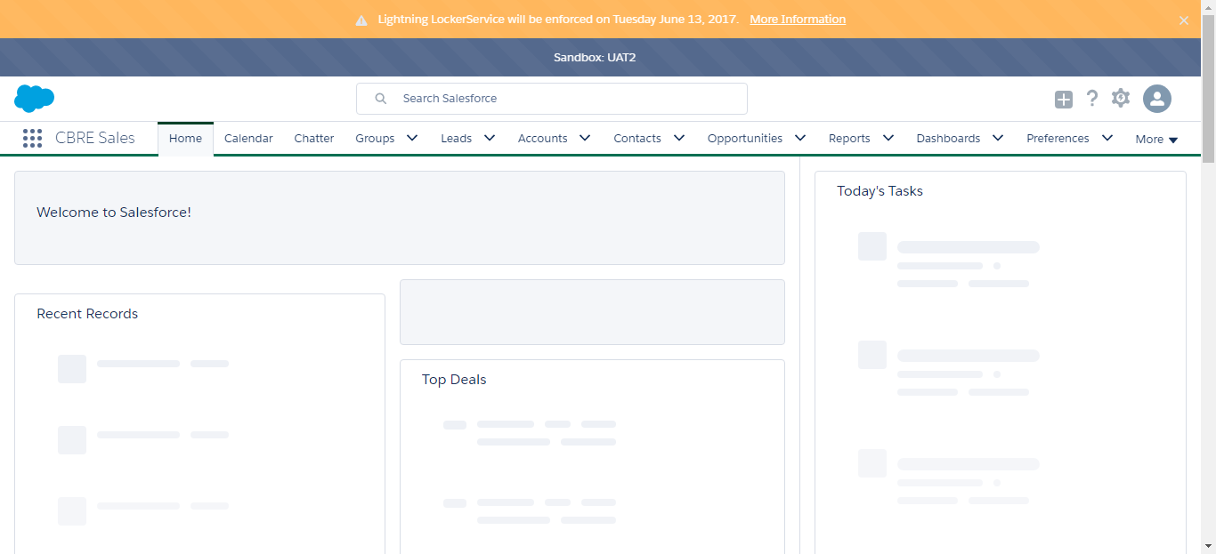

SF.SmokeTestScripts_TC_SF_ManagerLogin_Instance1_12-Apr-2017_01-29-15_PM_Verify_Logout.png

